- Chapter 3: Use and Occupancy Classification
  - Factory Group F
    - Factory Industrial Group F occupancy includes among others, the use of a building or structure, or a portion thereof, for assembling disassembling, fabricating, finishing, manufacturing, packaging, repair or processing operations that are not classified as a Group H hazardous or Group S storage occupancy
  - Moderate-hazard factory industrial, Group F-1 include (all relevant)
    - Appliances
    - Electronics
    - Furniture
    - Leather products
    - Machinery
    - Metals
    - Millwork
    - Textiles
    - Wood; distillation
    - Woodworking (cabinet)
  - Low-hazard factory industrial, Group F-2 (all relevant)
    - Metal products (fabrication and assembly)
- Chapter 5: General Building Height and Areas
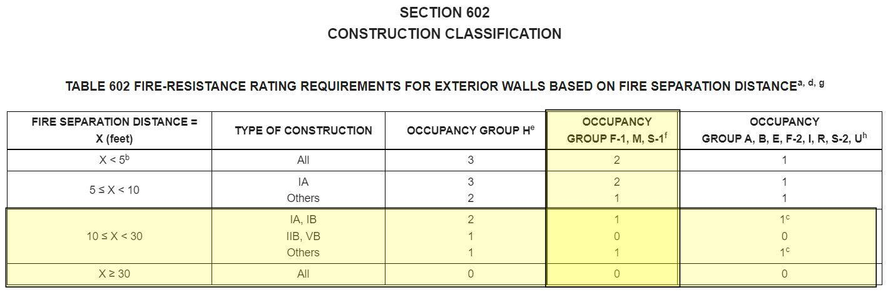
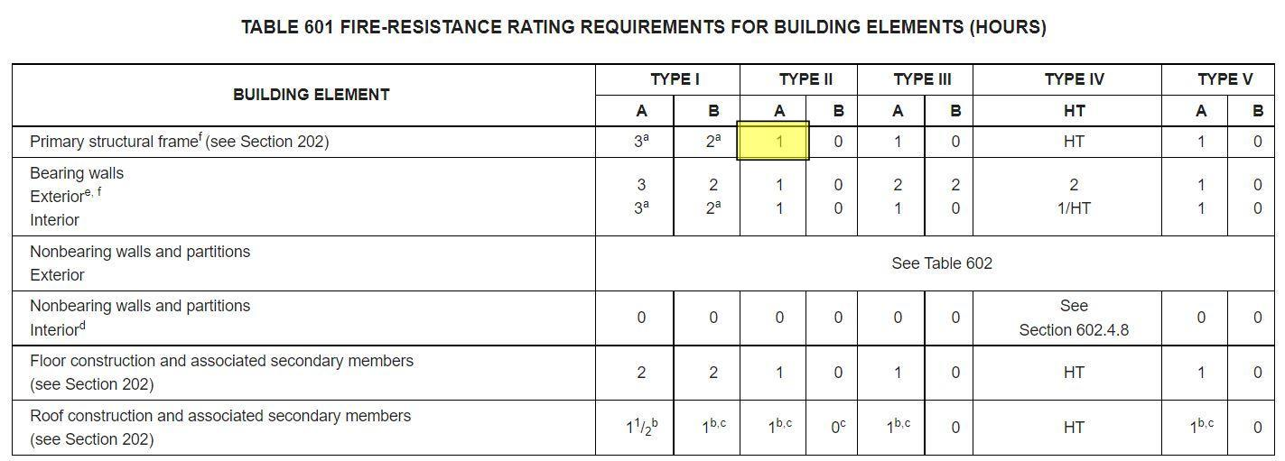
Because our building has a steel primary structure and a fire rating for at least an hour separating each of the rooms, it classifies as Type IIA.
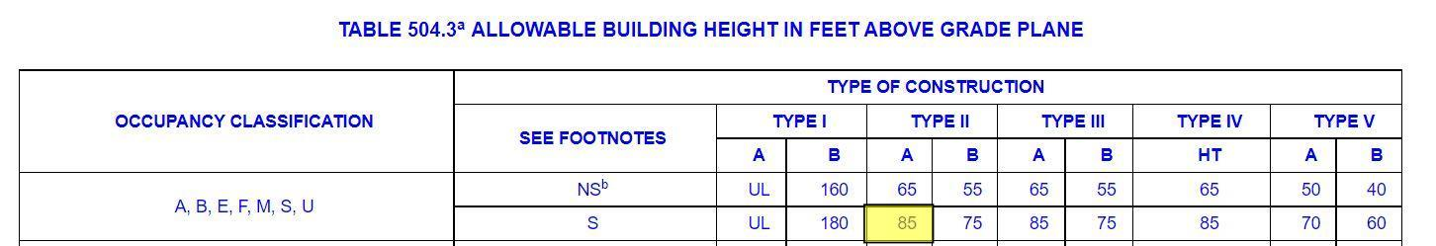
The allowable height of our building complies with the code requirements for Type IIA as the max height is 85’ and our only goes to 68’ at the peak of the roof.
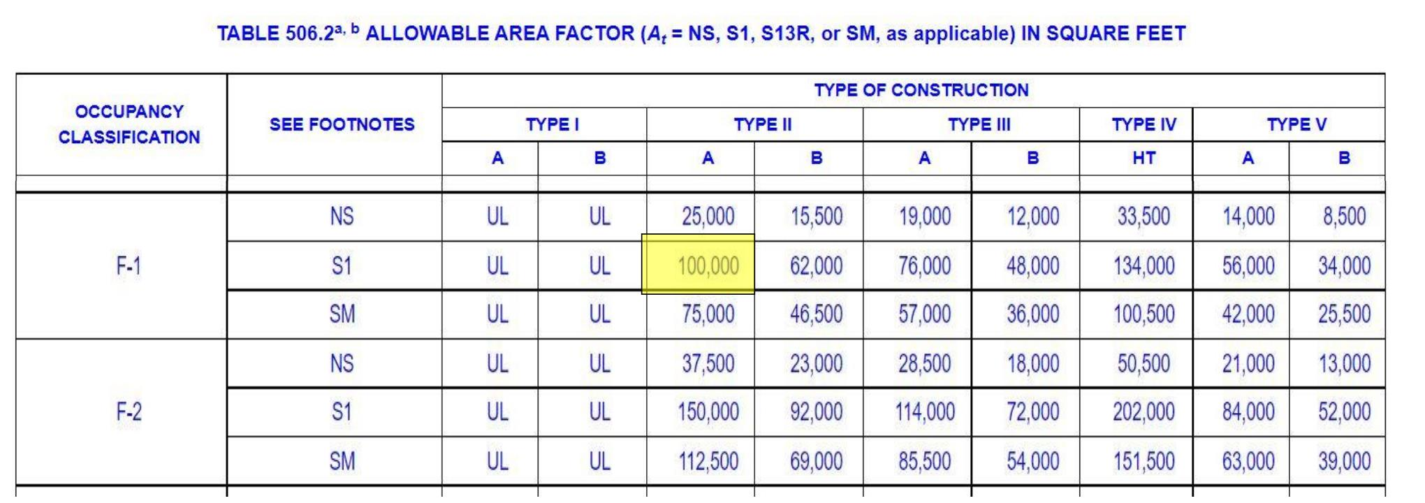
The total floor area of all floors combined only reaches 24,550 sf complying with the code.
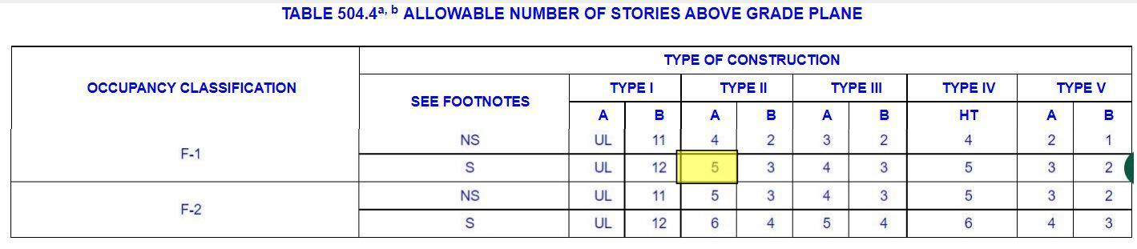
There are only 3 floors with a double height space on top only equaling 4 floors. Either way we comply with the code.
- Types of Construction
Each room is separated from each other with fire rated walls.
The elevator shaft and circulation spaces are separated by fire rated walls.
The workshop areas are double heighted spaces with special equipment, and will be protected with sprinklers as need be.
The floors are concrete slabs and fire rated.
- Fire Protection Systems
  - Section 903: Automatic Sprinkler systems
    - An automatic sprinkler system shall be provided throughout all buildings containing a Group F-1 occupancy where one of the following conditions exists:
      - A group F-1 fire area exceeds 12,000 square feet (1115 m2)
      - A group F-1 fire area is located more than three stories above grade plane.
      - The combined area of Group F-1 fire areas on all floors, including any mezzanines, exceeds 24,000 square feet
      - A group F-1 occupancy used for the manufacture of upholstered furniture or mattresses exceeds 2,500 square feet
    - The building total square feet is 24,550 square feet and goes up to a double heighted 3rd floor requiring automatic sprinklers through the building
  - Section 905: Standpipe Systems
    - Because this building has a landscaped roof, a standpipe system is required to be extended to the roof level.
    - Required on the interior of the exit stairway at each grade
  - Section 907: Fire Alarm Detection Systems
    - As these are only required for buildings where more then 500 people will be occupying a space above ground level, and ours will not accept this load, this building will not require fire alarms.
  - Section 909: Smoke Control Systems
    - This building has passive smoke control systems built into the double skin façade venting out the air and active systems in the duct work.
  - Section 910: Smoke and Heat Removal
    - Again, this is taken care of through the active and passive systems.
- Means of Egress
  - Section 1004: max floor area per occupant
When using the unconcentrated assembly without fixed chairs and seats, this allows 15sf per person. The first floor total area is 11,330 resulting in about 755 total occupancy for this floor. The second floor is only 3,740 leaving 249 people allowed. Finally, the third floor has a sf of 6,910 resulting in 460 people allowed.
  - Section 1006 – Determine the number of required exits per floor, all requirements for exits
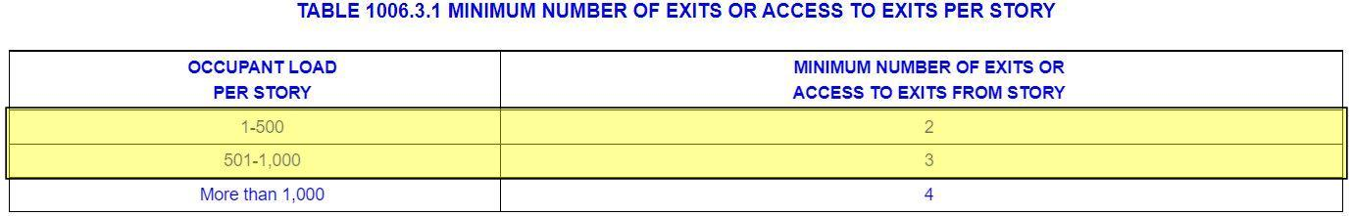
The first floor requires 3 exits and the second and third require 2. This is what this building has, so it complies with code.
  - Section 1007 – Determine the Exit and Exit Access requirements (reference the number exits and remoteness)
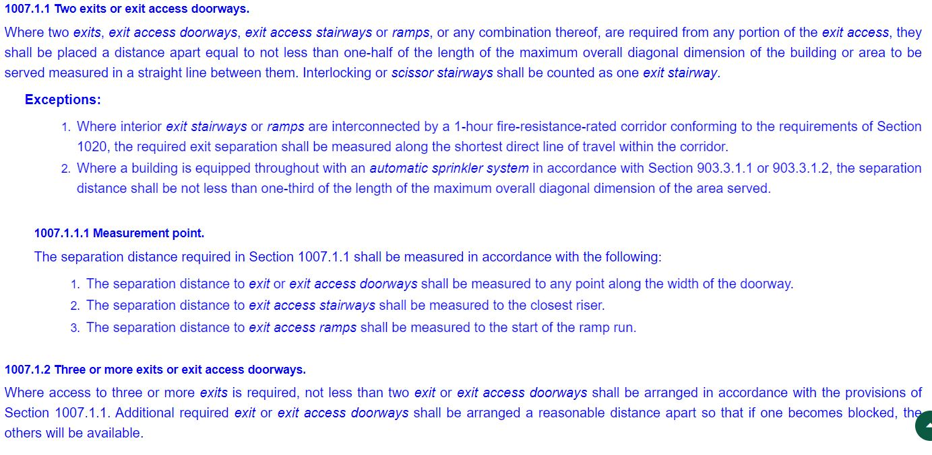
Where 3 doors are required, the max distance between the 3 is only 69’ which is less than half of the total diagonal distance of 167’. With this being said, they are on opposite ends of each wing and accessible from each, so it takes into account emergency access. The second and third floors comply as the exits stay in the same place, but the overall distance shrinks to 118’.
  - Section 1009 – Determine the Accessible requirements , including the stair riser, tread and rail requirements and sizes.
    - Elevators, stairways, and platforms all comply with code.
  - Section 1010 – Determine the min. door widths (clear), swing direction, fire rating
    - All doors are 36” x 84” and comply with door codes, swinging outwards, and are all fire rated.
  - Section 1005, & 1011 – Determine min stair width and any other requirements.
    - The rise to run is 7 inches to 11 inches
    - The minimum head height is 7 feet
    - The width of the stair width is 4 feet
    - Everything complies with code
  - Section 1005.3.2 and 1020.2 - Determine min. egress corridor width
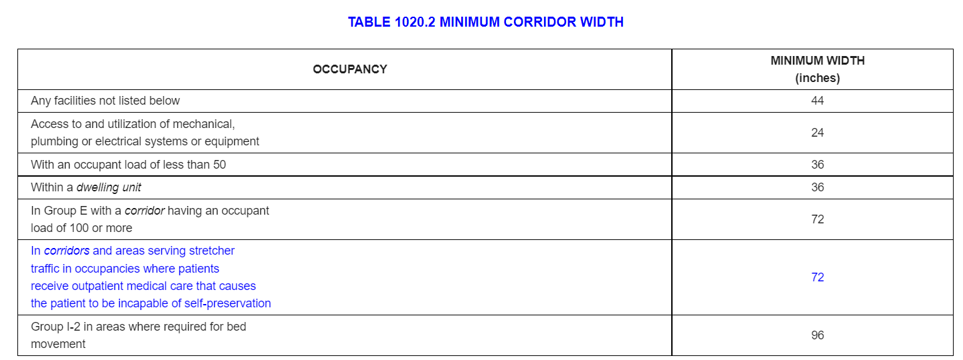
The minimum corridor size in the building is 5’ in a hallway between offices, otherwise the average corridor width is 15’
  - Section 1017.2 – Determine the max. distance of travel to exit (is this to the stair or corridor?)
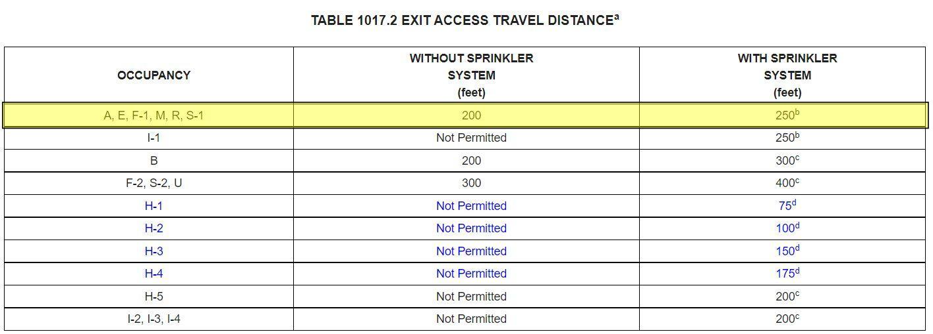
    - The max distance between stairs is 70 feet.
  - Section 1020.4 Dead Ends – Determine the max. length of dead end corridor
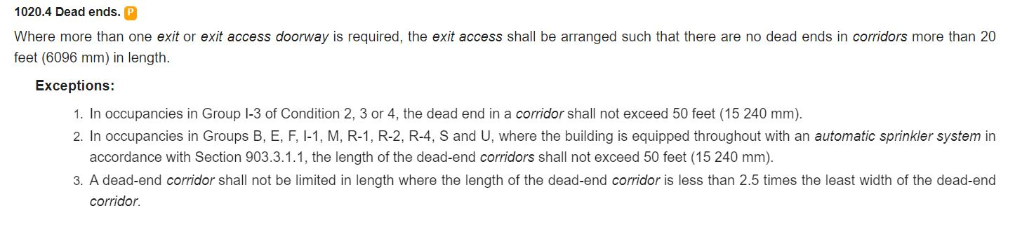
    - The max dead end corridor is 18’ complying with the code
Through this research, this building complies with code in all aspects.

